Results

The baseline expected annual agricultural profit per household is ¢224119 (at 5% statistical significance). The best model describing the variables influencing this profit is:

lm(profit ~ factor(region*ez) + factor(loc2))
(ez = ecological zone factor, loc2 = rural areas
F-statistic: 83.68, p-value: < 2.2e-16)
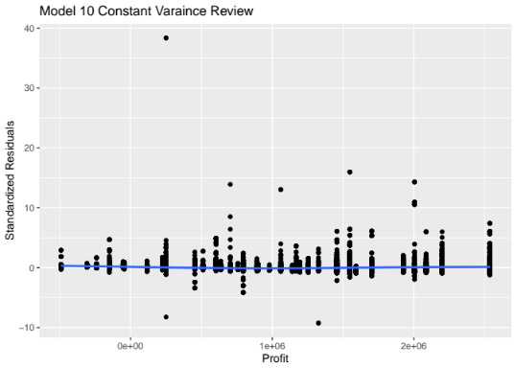
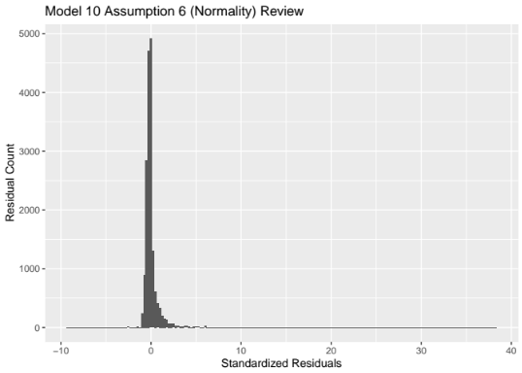
Of significances the model only includes household location variables. While this model’s distribution of errors is not normal (right tail) this distribution is typical of all the models evaluated. The evaluation of this model’s homoskedasticity; however, is the best with a near 0 mean and a somewhat constant variation among the residuals.
DTC-4 evaluated 2 hypotheses: (1) that household education and (2) the composition of the household work force (including hired help) have an influence on profitability.
The null hypothesis for education: that education did not have an impact on annual profit; however, could not be rejected. All levels of education completed by household members did not have a statistical significance when compared to a household education of none (factor level 0) with all other aspects of the base model were held constant. Additionally, the model removing of the education factor variable only had a .001 change in the R-square score, indicating that the education variable had a very limited influence on annual expect profits.
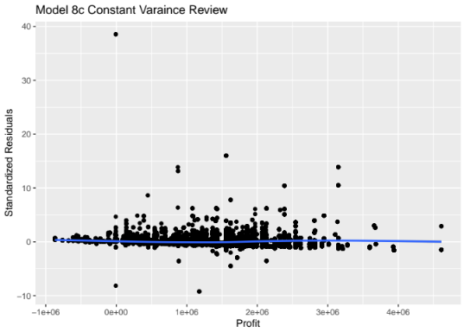
The null hypothesis for household work force composition could not be rejected, as all 13 model variations – including quadratics - that showed statistical significance at various levels but were not accepted as the final model. The best model (8c) maintained the right tail, as all the other error distributions, but had very limited heterskedasticity. Of note the interaction between the location variables.
The reason model 10 was adopted over 8c as due to the limited impact household workforce composition had to overall profit. The R-square for model 8c is 8.44 while model 10’s is 7.93. While household workforce composition influences annual expected profit, location variables and their interactions are the primary influences on expect annual profits.

Implementation

The base data frame included the following variables:

Dataframe Name | Alternate Name | Type | Definition
Region | N/A | Factor | Regions where household resides
District |  |  | District in individual regions where household resides
s2aq2 | N/A | Factor | Highest level of schooling completed
av_hh_age | agey | Numeric | Average age in years for household.  Determined by grouping individuals by  household id then - agey =  round(mean(agey), 1)
s2cq1 | Read letter in English | Factor
s2cq2 | Read in Ghanaian lang | Factor
s2cq3 | Can write in English | Factor
s2cq4 | Can write in Ghanaian lang | Factor
s2cq5 | Can do written calculations | Factor
ez | Ecological zone | Factor
loc2 | Locality classification | Factor
male | Sex | Numeric | Total number of males in household  Determined by grouping individuals by  household id then counting the number of applicable factor levels
female | Sex | Numeric | Total number of females in household
male_help | s8cq17a | Numeric | Taken directly from sec8c data set
female_help | s8cq17b | Numeric | Taken directly from sec8c data set

The correlation among the non-factor variables was:

 | male | female | family_size | av_hh_age | male_help | female_help | profit
male | 1.00 | 0.22 | 0.80 | -0.30 | 0.11 | 0.09 | 0.17
female | 0.22 | 1.00 | 0.72 | -0.32 | 0.10 | 0.05 | 0.11
family_size | 0.80 | 0.72 | 1.00 | -0.40 | 0.13 | 0.09 | 0.18
av_hh_age | -0.30 | -0.32 | -0.40 | 1.00 | -0.02 | -0.02 | -0.05
male_help | 0.11 | 0.10 | 0.13 | -0.02 | 1.00 | 0.15 | 0.12
female _help | 0.09 | 0.05 | 0.09 | -0.02 | 0.15 | 1.00 | 0.09
profit | 0.17 | 0.11 | 0.18 | -0.05 | 0.12 | 0.09 | 1.00

The base model was profit against all the data frame variables:

lm(profit ~ factor(region) + factor(ez) + factor(loc2) +
male + female + family_size + av_hh_age + factor(s2aq2) + factor(s2cq1) +
factor(s2cq2) + factor(s2cq3) + factor(s2cq4) + factor(s2cq5) +
male_help + female_help)
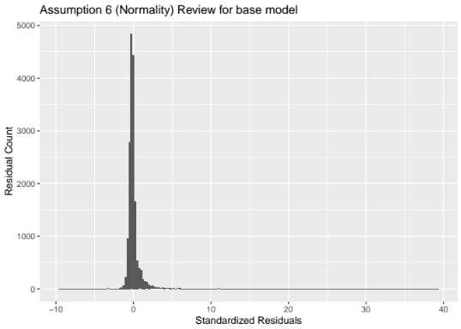
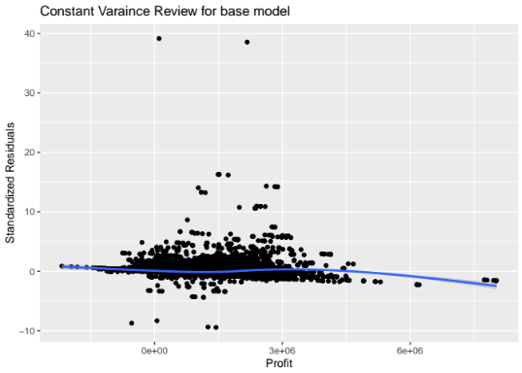

Using a backward variable identification process, each successful model removed the independent variable with the highest p-value. For example, model 4 removed the education, average household age, and literacy factor data leaving:

lm(profit ~ factor(region) + factor(ez) + factor(loc2) +
male + female + male_help + female_help)

Of interest the R-squared value went from 11.39 to 10.56 indication the removed variables offered little influence on the expected annual profit when compared to the remaining variables.
Once the variables had been reduced to location and household workforce related variables then the process transitioned to finding how interactions and quadratics could be used to improve homoskedasticity producing a better model - since the distribution of errors always maintained the right tail.

Model 6a: lm(profit ~ factor(ez) + factor(loc2) +  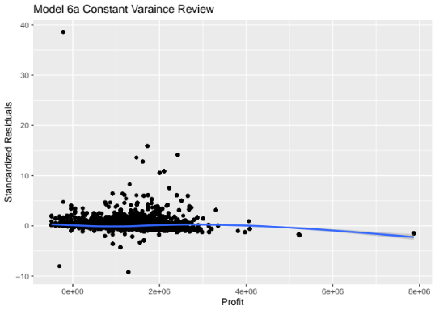  male + female + male_help + female_help) | Model 8c: lm(profit ~ factor(region * ez) + factor(loc2) + male + I(male^2))

